Project Design Phase-II
Technology Stack (Architecture & Stack)

Date | 3 October 2026
Team ID | SWTID-2026-9684
Project Name | Implement Client Script & UI Policy (Incident)
Maximum Marks | 4 Marks

Technical Architecture:
The solution uses ServiceNow client-side configuration to control Incident form behavior and validation.
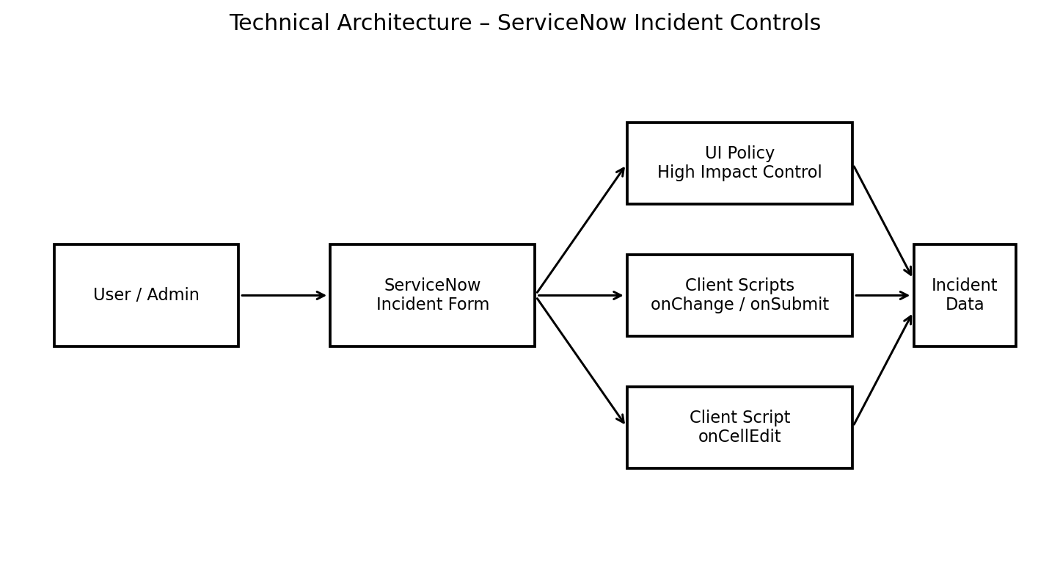

Guidelines:
Include all the processes (As an application logic / Technology Block)
Provide infrastructural demarcation (Local / Cloud)
Indicate external interfaces (third party API’s etc.)
Indicate Data Storage components / services
Indicate interface to machine learning models (if applicable)


Table-1 : Components & Technologies:
S.No | Component | Description | Technology
1 | User Interface | Incident form and Incident list used by ServiceNow users. | ServiceNow Incident Form / List UI
2 | UI Policy | Applies conditional field behavior when Impact is High. | ServiceNow UI Policy / UI Policy Actions
3 | Client Logic – onChange | Automatically sets Urgency to High when Impact changes to High. | ServiceNow Client Script / GlideForm (g_form)
4 | Client Logic – onSubmit | Validates Assigned To before saving a High impact Incident. | ServiceNow Client Script / GlideForm
5 | Client Logic – onCellEdit | Blocks direct State changes from list editing. | ServiceNow Client Script / onCellEdit
6 | Data Layer | Stores Incident fields and configuration records. | ServiceNow Platform / Incident Table
7 | Testing & Validation | Verifies mandatory behavior, successful save, reverse condition, list blocking and form update. | ServiceNow Incident test cases
 | External API-1 | Purpose of External API used in the application | IBM Weather API, etc.
 | External API-2 | Purpose of External API used in the application | Aadhar API, etc.
 | Machine Learning Model | Purpose of Machine Learning Model | Object Recognition Model, etc.
 | Infrastructure (Server / Cloud) | Application Deployment on Local System / Cloud  Local Server Configuration:  Cloud Server Configuration : | Local, Cloud Foundry, Kubernetes, etc.

Table-2: Application Characteristics:
S.No | Characteristics | Description | Technology
1 | Open-Source / Platform Frameworks | Uses ServiceNow platform configuration and client-side scripting for the project. | ServiceNow UI Policy, Client Scripts, JavaScript
2 | Security Implementations | Restricts invalid submission and unauthorized direct State list edits through client-side controls. | UI Policy, Client Script validation
3 | Scalable Architecture | Business rules are separated into reusable UI Policy and event-based Client Scripts. | ServiceNow platform configuration
4 | Availability | The solution runs within the ServiceNow platform and applies controls on Incident interactions. | ServiceNow platform
5 | Maintainability | Each control has a clear name, event type, field target, and test scenario. | ServiceNow configuration records

References:
Project source: Implement Client Script & UI Policy (Incident)
https://c4model.com/
https://developer.ibm.com/patterns/online-order-processing-system-during-pandemic/
https://www.ibm.com/cloud/architecture
https://aws.amazon.com/architecture
https://medium.com/the-internal-startup/how-to-draw-useful-technical-architecture-diagrams-2d20c9fda90d

